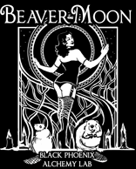
SHUT YOUR TRAPS FOR THE BEAVER FOOL MOON – NOVEMBER 4TH, 2017
CUM WARM YOUR BEAVERS WITH A NIGHT OF TRAIL AND BEER!
WHERE: Allegheny 6 Pak and Doghouse – 1301 Pittsburgh St. Cheswick, Pa. (use your GPS)
WHEN: 11/4/17 – 6PM – The hash leaves when the beavers dam feel like it!
HARES: Sex Pak and VueGina
WHAT: Bring some cash, trail will be contra, the après will have food and plenty of beer. You will need money if you want draft or any specialty beers to drink.
Flashlights are advised as night is dark and the clocks turn back at Midnight.
If you want to stay overnight at The Y Not Stop Inn, (SP’s place) bring gear, etc for the Sunday trail. Call me to reserve a space and info. 20 Gunther Rd., Cheswick, Pa. It’s about 5 miles from the 6 Pack Shop.
Phone – 412-508-5366 cell, 724–265-4267 The Y Not Stop Inn, email davidalockerman@aim.com
Uninteresting Farmer’s Almanac facts:
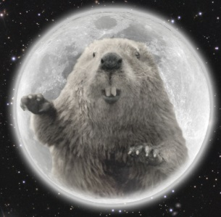
November 3rd, 2017: November's full Moon is sometimes called the Beaver Moon because it was the time to set traps, before the waters froze over. This Moon was also called the Full Frost Moon.
This November the exact time of the Full Moon will be just before midnight on Nov 3rd for the West Coast and Mountain timezones and just after midnight for Central and East Coast United States.

